**The COVID-19 Policy Response: How Helpful Were Nontraditional Data Sources?**

**By Tomaz Cajner, Laura Feiveson, Christopher Kurz, and Stacey Tevlin**

1. **Introduction**

Over the last decade, an explosion of data collection has led to a robust set of nontraditional data sources for policymakers to lean on when constructing policy. In “normal” times, existing and time-tested datasets compiled by government statistical agencies often do a good job of capturing the evolution of the economy at the monthly or quarterly frequency accurately and without bias. However, when the economy turns quickly—time periods when policymakers need to be particularly responsive—nontraditional data sources may be able to fill important gaps. The COVID-19 crisis provided a test case of the usefulness of these alternative data sources. In this paper, we explore how nontraditional data sources aided—or, in some cases, did not aid—policy decision-making during the pandemic recession and what lessons we can learn for future crises.

We organize the paper around examples that highlight the three main potential benefits of nontraditional data sources relative to their government counterparts. The first possible benefit is what we will call “timely measurement” of the economy, meaning the use of nontraditional datasets to learn in real time about aggregate statistics that are released by the government with some lag. One example is transaction data from card swipes and e-commerce from financial payments firm Fiserv, which have been bundled to track household spending. The Fiserv data come out with only a few days delay in contrast to government statistics: Census reports of monthly retail sales (which make up about one third of spending) are released two weeks after the month’s end, and Census surveys on services spending (which covers about one third more of total spending) come out with a quarter lag. We argue that the benefit of such timely measurement is important to policymakers, especially in times of sharp contractions, such as what we experienced in March of 2020.

The second benefit that we highlight is “granularity”, i.e. that due to the granular nature of some of the nontraditional data sources, they may provide reads on aspects of firm or consumer behavior for which there is no standard government data source (even with a lag). The finer granularity could be related to frequency (such as daily data), geography (data broken down by region), or demographic groups (data broken down by income, for example). The geographic breakdown available in the Fiserv data is an example of such granularity. Because the data are broken down by state, it was possible to track the effect of the pandemic on spending as waves of cases hit different parts of the country. Generally, being able to do granular analyses in almost real-time could allow for faster evaluations of the costs of shocks or the benefits of policies, which, in turn, could serve to fine-tune subsequent policy actions.

The final benefit of nontraditional data that we discuss is “crisis-specific data gathering”. The availability of data from so many different sources allows policymakers to access data that will answer specific, unanticipated questions that are unique to a particular crisis. A clear example is the plethora of data related to health and social distancing during the COVID-19 pandemic. For these unique types of uses, it is not clear that investment in generating these statistics during normal times would be even worth the cost, underscoring the importance of quick access in times when they are.

The last section dives into the pitfalls of nontraditional data, and how we can learn from what did not go well in their usage over the COVID-19 crisis. Unlike government statistics, most alternative data sources are not designed with the purpose of generating statistics but are instead a byproduct of another use (such as card transactions). As such, the data are not designed to be representative of consumers or firms, and may be hard to interpret, or, worse, misleading. It is from these pitfalls, that we must take the most powerful lessons of what we need to work on to be ready for the next crisis.

To assist in the discussions of measurement, granularity, data gathering, and pitfalls, we compiled a summary table at the end of this paper of nontraditional data and sources we have been exposed to and leveraged for analysis. The table, while certainly not exhaustive, contains a list of indicators from five categories, covering spending and confidence, employment, health, mobility, and “other”.

1. **Timely Measurement of the Economy**

We start our exploration by considering how the timely measurement benefit of nontraditional data may have influenced policy decisions in the spring of 2020—a time of historically acute economic change. As Figure 1 shows, as events rapidly unfolded, much of the critical policy decisions were made *before* the release of any government data. In fact, the Fed’s emergency rate cuts and new facilities were announced, and the CARES act was passed, before any government data containing signs of the downturn were released. On the face, this suggests that the policymakers may have relied on nontraditional data sources to guide their decision-making. While this is certainly true, as we explore below, it is also worth noting that some of the policy actions were taken before there was any downturn in the US at all. In particular, the Fed’s emergency rate cuts were done in early- and mid-March, before there was a US lockdown, and the discussions about facilities and the CARES act were underway before COVID-19 had taken hold of the US economy. During these times, policymakers importantly relied on non-government, but still traditional, sources to guide these initial actions—financial movements and news of shutdowns abroad (in China and Italy)—as well as on analysis by epidemiologists regarding the likely spread of COVID-19, along with calibrations by economists on the resulting impact on the economy.[1]

**Figure 1: Early Policy Responses to COVID-19**

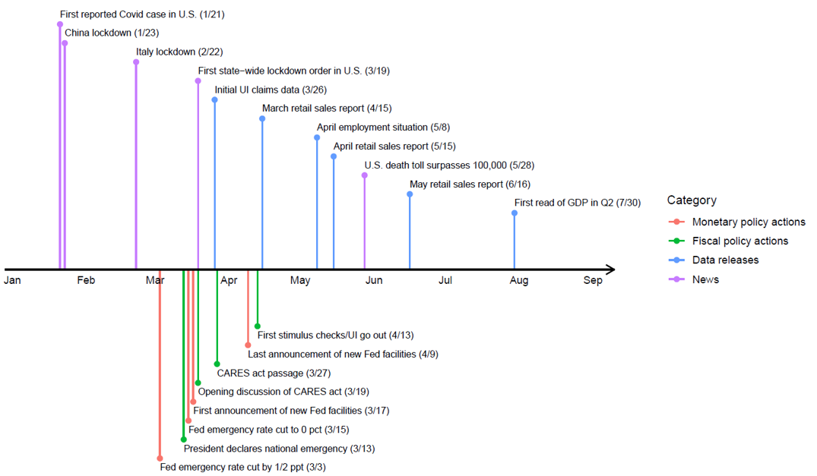

Still, once the pandemic did take hold in the US, nontraditional data sources filled in a crucial gap in corroborating the enormous effects of the pandemic on employment and on spending before government data itself came out. Figure 2 shows how the use of data from a large payroll processor, cleaned and refined by economists at the Federal Reserve Board into a data source we call ADP-FRB, was able to reveal the labor market damage in real time.[2] The BLS report released at the beginning of April, which only covered the week including March 12th, did not reflect these declines, so it wouldn’t have been until the beginning of May that these employment losses would have been seen in the standard data.[3] In contrast, by the end of March and the beginning of April, when the final Fed facilities were decided upon and announced and when the CARES act was passed, policymakers with access to the ADP-FRB data would already have been able to see the staggering amount of job loss taking place, driven in a large part by employment declines in the leisure and hospitality sector.[4] Note that the ADP-FRB data for a given week are available with a lag of about one week, which translates into learning information about the week of the BLS CES survey about two weeks before the BLS releases its data.

**Figure 2: Snapshots of Employment Data**

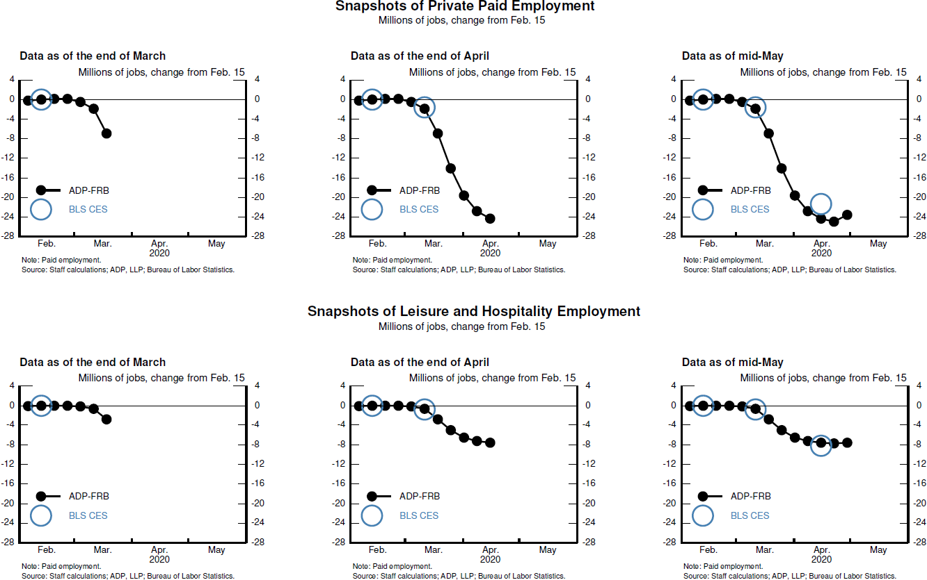

The nontraditional data on spending filled in a similar gap. Figure 3 shows some of the spending data that would have been in hand at three snapshots in time: the end of March, mid-April, and mid-May. Like the ADP-FRB data, the nontraditional spending data were able to capture the severe downturn in spending in COVID-sensitive categories by the time policy decisions were taken at the end of March. Furthermore, even by mid-May, the government data in hand were incomplete in that they covered only a narrow portion of COVID-sensitive services—food services & drinking places—in addition to the sales of retail goods, which were of less use since they were much less affected by social distancing than services categories.[5] The nontraditional data such as those shown here—the restaurant reservations from OpenTable, airport departures from TSA, and card transaction data from Fiserv—were crucial for quantifying the impact on the economy during that time.

**Figure 3: Snapshots of Consumer Spending (percent change from same period in 2019)**

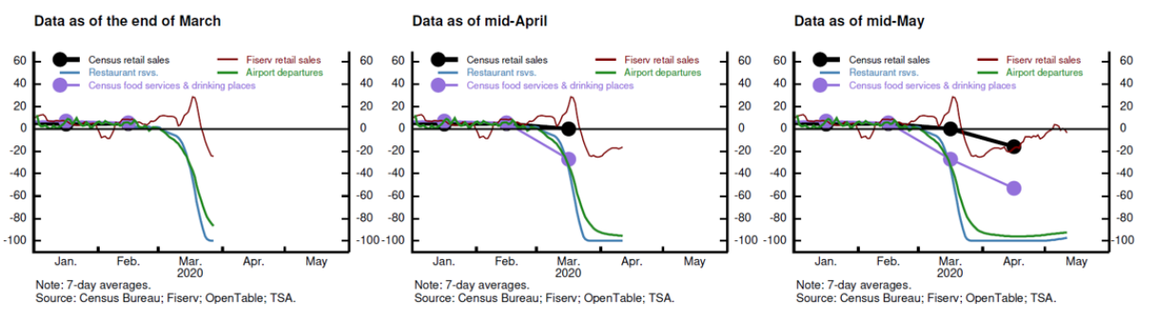

So, even though the initial policy actions and the discussions of further actions were kicked off before the economic slump began, the corroboration provided by the nontraditional data sources may have hastened the final decisions on the CARES act and the Fed facilities. Had policymakers had to wait until May for the release of government data to fully understand the magnitude of the impacts of social distancing, it is possible that some of their policy actions may have been smaller, less well targeted, or delayed by one month or more.

Had that delay occurred, what might have been the cost? It is hard to know for sure, and it is possible that the costs would not have been that high. However, there are risks that would have been heightened by a smaller policy response or a delay. Regarding the Fed’s role, it is likely that a delay in some of the facilities would have led to greater disruptions in the financial system, as uncertainty and a loss of confidence would have worsened. Even just the announcement of the facilities led to rapid improvements in financing conditions in bond markets, narrowing spreads, and increasing access to markets for many issuers. If the Fed had been delayed, a flood of defaults on loans to businesses may have led more businesses to close their doors permanently, leading to costly reallocation that might have greatly slowed the recovery. As we learned in the Great Recession, this type of dislocation is hard to reverse and may have lasting impacts on the economy. On the fiscal policy side, the CARES act provided needed assistance to individuals who lost their jobs in the pandemic and was essential for households with little savings or outside support. The longer these households went without support, the longer that some households may have gone without food or other necessities. They might also have cut back sharply on discretionary spending, slowing the economy more. Furthermore, without the prospect of immediate support, some vulnerable households may have felt the need to liquidate longer-term assets such as retirement funds or housing, which, in turn, could have had long-lasting and negative effects on their economic wellbeing and led to further fragility in financial markets. Finally, without the prospect of immediate and substantial support, some workers may have returned to unsafe working conditions too early, and, in doing so, may have worsened the pandemic.

Thus, the nontraditional data likely played some role, and possibly a consequential one, in supporting both monetary and fiscal policy actions. But, the sharp downturn of March 2020 is an anomaly in the modern era—can a case be made more generally that the timely measurement benefit of alternative data is worth investing in?

Even in more normal times or more typical downturns, nontraditional data allowing for timely measurement can still provide policymakers with an important tool. Although the benefits are hard to quantify, they can be substantial. First, government data themselves revise and are measured with noise, and the alternative data provide another source from which policymakers can make inferences about the state of the economy. Second, the timely aspect of the data—i.e. that they lead the government data by a few weeks to a few months—is important for timely policymaker decision-making. It could also be important for communication, as describing the state of the economy accurately in real time can only help policymaker credibility. Third, nontraditional data sources can substitute for government statistics at times when government data themselves are delayed, such as during a government shutdown.[6]

We turn to two examples of these benefits from the Great Recession. The constellation of data the Federal Reserve observed in mid-2007 provided a markedly different signal from what we now view as the economic situation prior to the start of the Great Recession.[7] Specifically, at the August 7, 2007 meeting of the FOMC the committee had in hand—amongst other indicators—the first print of the July employment data from the BLS and estimates of second-quarter GDP from the BEA. For employment, the July employment report reported gains of 92,000 for nonfarm payroll employment and the Greenbook—the Board’s policy document at the time—noted that “[l]abor demand has continued to run slightly ahead of our expectations, with private nonfarm payrolls up an average of 115,000 per month over the last three months”. In terms of GDP, at the time the BLS had published an estimate of real GDP growth of about 3.4 percent in the second quarter and policymakers were looking at a first half growth rate of roughly 2 percent. Overall, in real time growth appeared to be holding up in the two primary indicators of an economy’s wellbeing.

In retrospect, and with fully revised data in hand, the economic landscape was somewhat less supportive of growth than was thought at the time of the August 2007 FOMC meeting. Specifically, fully revised employment decreased 33,000 in July and the average growth over the three-month period mentioned above was 93,000. In terms of total output, the current vintage of average real GDP growth over the first half was 1.2 percent, roughly ¾ percentage point lower than estimates. Had the revised data, or an expansive set of nontraditional data, been in policymakers’ hands at the time of the August meeting, a better picture of a less robust state of the economy might have assisted policymakers. That is, more information could have pulled forward the view that things were weakening in the broader economy.

Another example, and as shown below in Figure 4, during the COVID-19 crisis the ADP data have done a terrific job of tracking the employment gains seen in the BLS employment situation, suggesting that these two datasets are indeed capturing the same concept. But they are not always exactly aligned, in which case analysts can better approximate the true state of the world from *both* of them together, which is particularly important when they temporarily diverge as argued by Cajner et al. (forthcoming). The latter paper also finds that during the Great Recession ADP-FRB data provided a better signal of employment losses than CES data; by August 2008 real-time CES estimates showed job losses totaling about 750,000, while ADP-FRB was at approximately 1.0 million (both numbers should be compared with the current vintage estimate of 1.4 million jobs lost).

**Figure 4: ADP and BLS Measures of Employment**

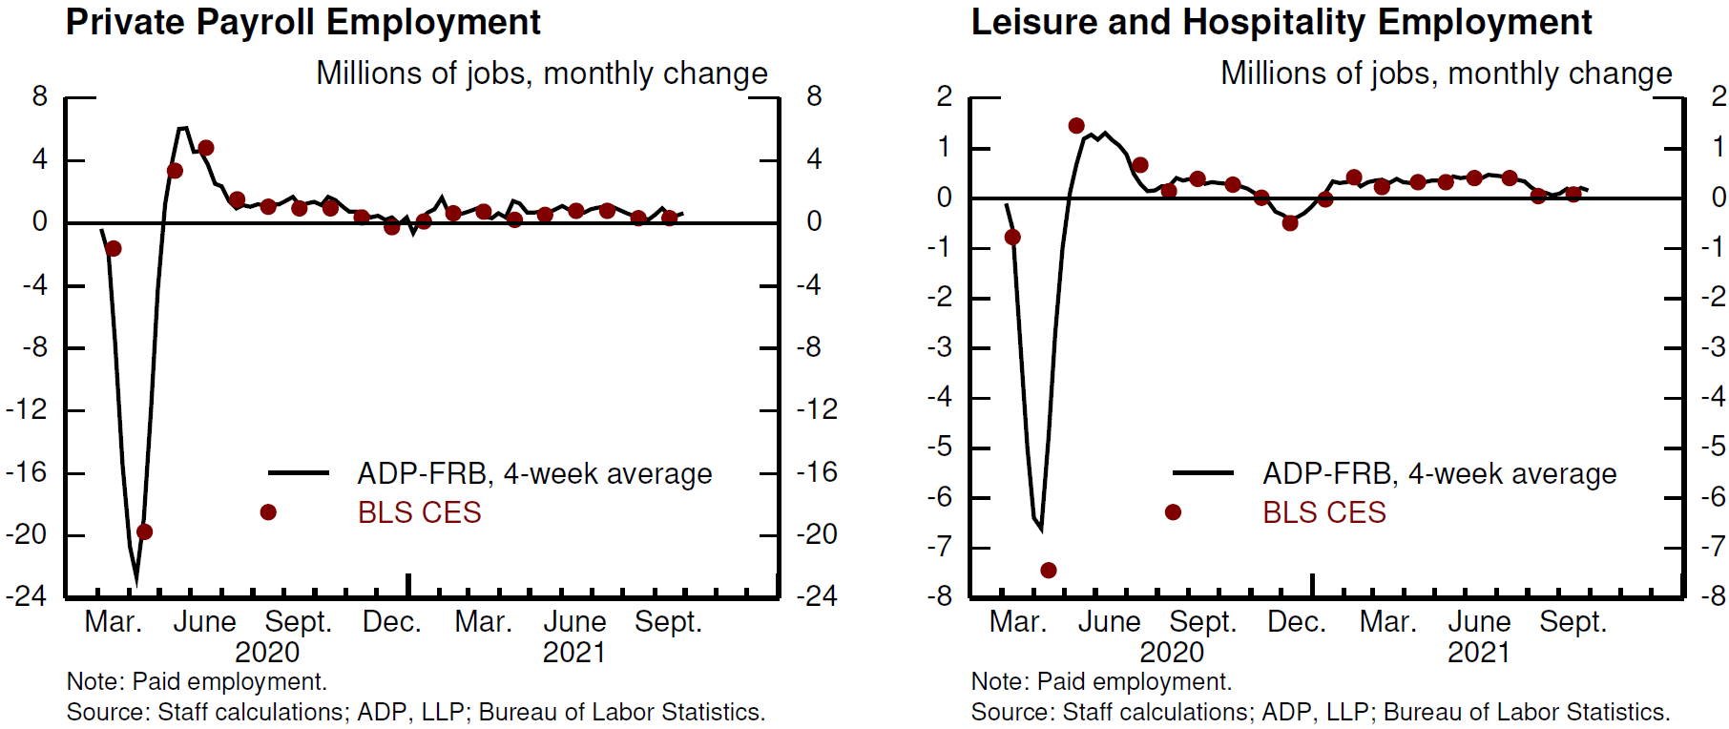

1. **Granularity**

In addition to providing timely information about aggregate statistics, nontraditional data often also allow for more detailed measurement, which we refer to as “granularity”. Examples of granularity include economic measurement across geographic areas (e.g., states, counties), industries, different individual characteristics (e.g., income), and high frequency time periods. Sometimes such granular information is also available in official statistics, but typically only with very long lags. In this section, we will discuss three main benefits of granular data. First, by providing information beyond that in aggregate statistics, granular data can lead to better understanding of real-time developments. Second, this understanding could lead to a more targeted policy response. Third, timely analysis with granular data can lead to essentially real-time policy evaluation, which can in turn also inform follow-on policy actions. We will illustrate these benefits with examples during the Pandemic Recession.

* 1. ***Granularity and understanding of real-time developments***

During the early weeks of the first wave of the pandemic, Northeastern parts of the country—in particular, states of New York, New Jersey, and Connecticut—experienced more severe COVID-19 outbreaks than the rest of the country (Figure 5, left panel). At that point, the economic effects of the pandemic were pretty much unknown and could also not be well assessed with aggregate statistics. Instead, the geographical variation available in nontraditional data helped to better understand links between health shocks and responses of economic variables. For example, many analysts turned to data on public transportation in New York (Figure 5, right panel) to get a better understanding on how individuals and businesses would react to rising COVID-19 cases. Similarly, employment data at the state level were used to better link job losses to COVID-19 outbreaks and many papers, which started appearing in summer of 2020, used state/county-level employment data to distinguish between economic effects of voluntary responses and state-mandated restrictions. The availability of granular data for the early-affected areas allowed us to get a better estimate of how severe the pandemic was likely to be for the country as a whole; indeed, at that point, aggregate data would not have picked up the severity.

**Figure 5: COVID-19 and Employment**

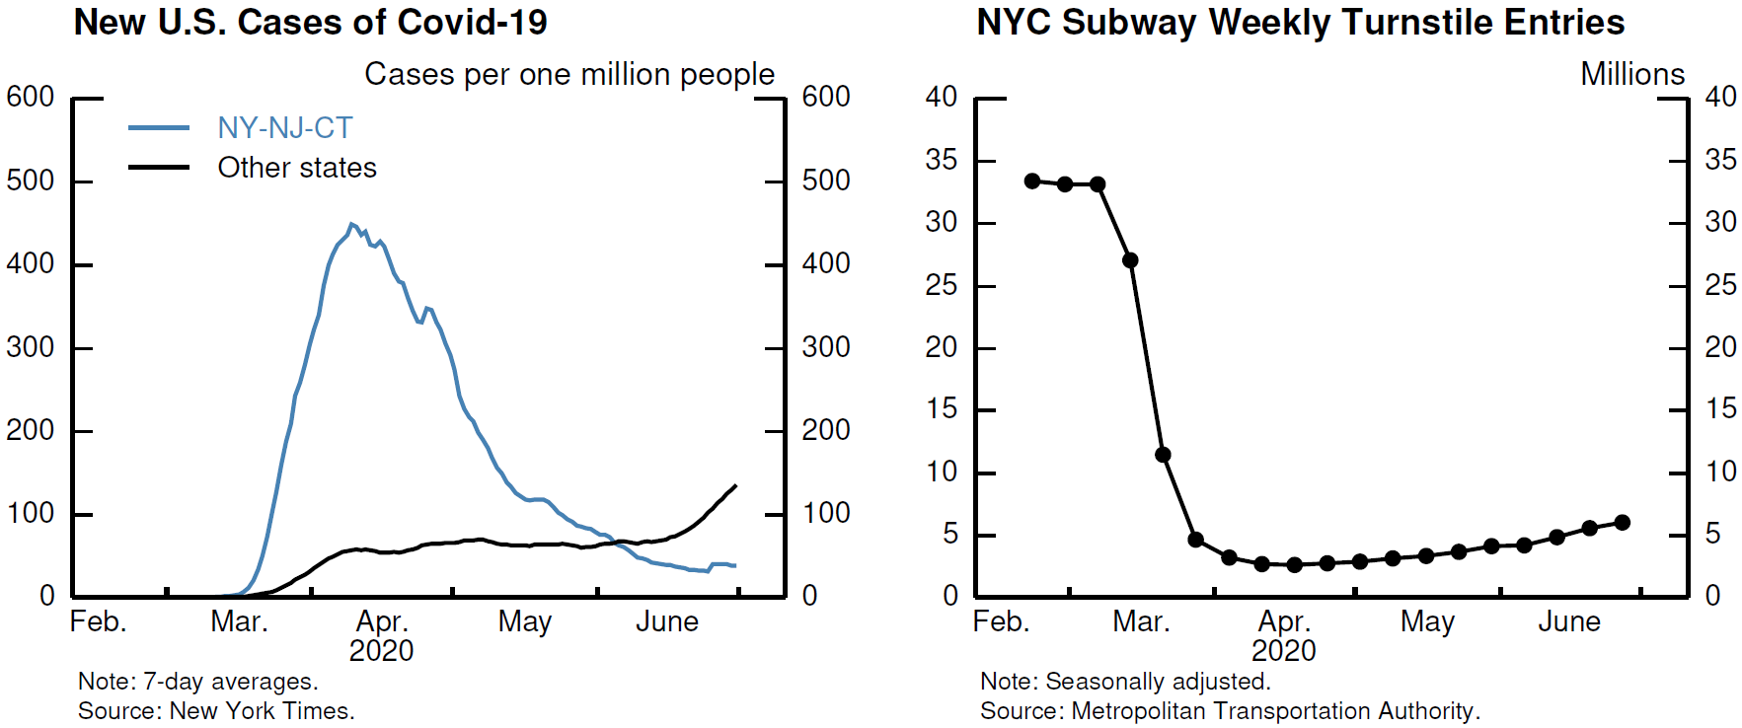

* 1. ***Granularity and policy design***

Another important example of granularity is the distribution of job losses during the pandemic recession, which was important for the design of many policies during that period. For example, the Pandemic Recession had much larger employment effects on some service industries, such as leisure and hospitality, mostly due to voluntary and mandatory social distancing. Those industries are also more likely to employ low-wage workers. As a result, employment of workers in the bottom quartile of the wage distribution fell substantially more than employment of workers with higher incomes, as shown in the left panel of Figure 6. Knowing the distribution of employment losses by wage helped to better design policy responses for unemployment insurance compensation and better target stimulus checks. In turn, these policies helped to support consumer spending for the low-income group, as shown in the right panel of Figure 6.

**Figure 6: Employment and Spending by Income**

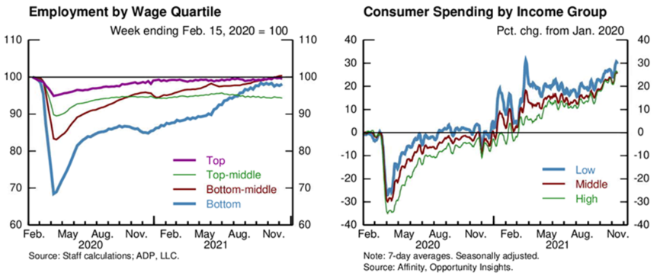

* 1. ***Granularity and real-time policy evaluation***

Finally, access to real-time granular data opens the door to real-time policy analysis. In turn, this analysis can be used to fine-tune subsequent policy actions.

One of the clearest examples of this in the Pandemic Recession is the analysis done to study the three rounds of stimulus checks that went out in April 2020, January 2021, and March 2021. One granular dimension that was immediately useful to track the effectiveness of the stimulus checks in promoting spending was the high-frequency nature of some of the nontraditional data. As Figure 6 shows, the Fiserv daily spending index was able to highlight surges in spending associated with stimulus check receipt that would not have otherwise been evident from the monthly data reported by Census. Other types of granular household-level data led to even more detailed estimates of the response to the stimulus checks. Using household balance sheet data, some researchers were able to publish estimates of the response to the first round of stimulus checks within a few months of the disbursement (Baker et al., forthcoming; Chetty et al., 2021; Cox et al., 2020). These early analyses of the response to stimulus checks showed that even when services spending was very constrained due to social distancing, households, especially lower income ones, still managed to spend significantly out of their stimulus checks. When the second and third rounds of stimulus were planned, these analyses already were available to lean on to inform policymakers of expected outcomes. Other important examples of real-time analysis done, but not discussed here, was on the Paycheck Protection Program (Autor et al., forthcoming; Chetty et al., 2021; Hubbard and Strain, 2020) and the unemployment insurance benefits (Coombs et al., 2021; Ganong et al., 2021).

**Figure 6: Spending**



These types of real-time analyses are not a panacea for policy design. They are only useful to the extent that they are accurate and available to and acted on by policymakers. When the analysis is conducted by researchers outside of government using privately sourced data, it is both difficult for policymakers to control the subject of the analysis and time-consuming for government actors to vet the data and the quality of the analysis. Still, in the case of the Pandemic Recession, there is some evidence that policymakers leaned on the work of Opportunity Insights to determine the income thresholds in the second and third rounds of stimulus.[8] And, the realization that this type of analysis is possible opens the door for future policymakers to actually plan to condition future policy on the outcome of real-time analysis. This would be especially possible if government agencies contract with nontraditional data sources such that they are prepared to do some of this analysis in house or if they contract with outside researchers to carry out and report the analysis. This type of analysis could even be an explicit part of a policy’s design and legislation—in the same way that the Council of Economic Advisors was legislated to provide quarterly reports on the effectiveness of the American Recovery and Reinvestment Act after the Great Recession.

1. **Crisis-Specific Data Gathering**

One important aspect of the pandemic episode was that the information policymakers needed to make their decisions differed markedly from a typical economic downturn. As a result, there has been a lot of crisis-specific data gathering that was carried out by official government agencies, but also by private data providers. Most notably, during the pandemic policymakers paid particular attention to health-related indicators—such as COVID-19 cases, hospitalizations, deaths, R0, vaccinations—since those were highly informative about possible disruptions to the economy. The importance of health-related data was, for example, reflected in FOMC statements which said that “[t]he Committee's assessments will take into account a wide range of information, including *readings on public health*, labor market conditions, inflation pressures and inflation expectations, and financial and international developments” (emphasis added).

At the start of each COVID-19 wave, policymakers tried to understand how fast a particular COVID-19 variant would spread and how severe the associated health outcomes can be. This information was used to predict possible behavioral responses of consumers and businesses, which in turn allowed for assessment of possible economic effects of each COVID-19 wave. While the importance of health-related indicators is obviously specific to a pandemic recession, it is worth noting that other nontypical economic downturns could also require gathering of crisis-specific data; to give one example, a climate disaster leading to a recession would likely require gathering timely, granular data on agriculture, migration, or weather patterns to better understand the possible evolution of the economy in real time.

Most of the health-related indicators that were informative during the pandemic did not exist before the pandemic. While official health agencies worked hard to provide the necessary health-related data during the pandemic, it is important to also emphasize the role that the private sector played. For example, institutions such as Johns Hopkins University, New York Times, and the collaborative volunteer-run COVID Tracking Project provided high-quality and regularly updated health data, including at very granular levels (e.g., by state or county and by demographic characteristics).

In order to better understand some specificities of the Pandemic Recession, several new statistics have been also developed. First, school instruction policy had important consequences for the labor supply decisions of parents with young children. Thus, policymakers followed closely data on shares of schools with in-person, hybrid, and remote instruction policy (Figure 8, left panel). As school districts varied in terms of their school instruction policy, these data were not readily available and were thus gathered by private sector companies (such as Burbio). Second, soon after the start of the pandemic, office occupancy dropped precipitously, either because businesses switched to remote work or because they had to (temporarily) lay off their employees. The data on office occupancy (Figure 8, right panel), which were again provided by the private sector companies (e.g., Kastle Systems), were used to measure in real time how quickly employees stopped coming to offices, but also later during the pandemic how quickly businesses returned to in-person work. Third, mobility measures—obtained, for example, from mobile phone data as in the case of SafeGraph data—were used to measure how many people were socially distancing by staying at home or by less frequently visiting different services providing businesses. Fourth, many analysts initially feared that the Pandemic Recession would lead to a burst of business exits and thus leave permanent damage to the productive capacity of the economy. Official statistics on business exit (and entry) are available with long lags (at least a year or even more), but some nontraditional data (from private data sources, such as ADP, SafeGraph, Womply, and Homebase) allowed measurement of business exit and entry essentially in real time and thus allowed a better assessment of potential scarring effects in the economy.[9] These data thus had the potential to affect future-looking policy or decisions about extensions of different policies, such as the Paycheck Protection Program. Finally, in the wake of the Pandemic Recession, several supply-side bottlenecks severely impacted the ability of the economy to recover and also lead to notably inflationary pressures. Nontraditional data, such as shipping waiting times, were helpful to measure the extent of those bottlenecks in real time.

**Figure 8: School Instruction Policy and Office Occupancy**

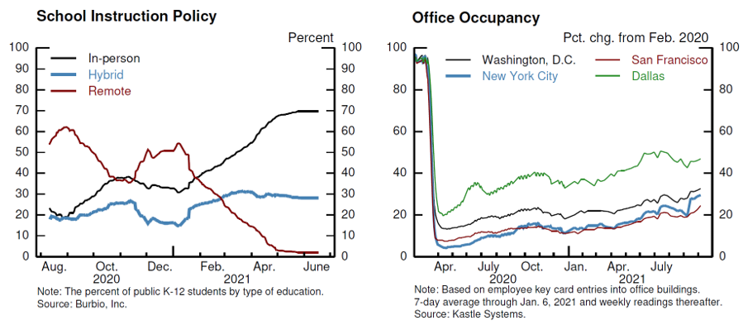

To summarize, there are some variables that are not providing much (or any) information about the overall path of the economy during “normal” times and thus we would not think of tracking them even with an unlimited budget for data. However, during the pandemic crisis they turned out to be crucially important, because they provided qualitative, and, at times, quantitative understanding of current developments and thus they informed the policymaking process. Gathering these crisis-specific data have often required a lot of resources. If subsequent economic downturns also happen to differ from a typical recession, it might be helpful to provide some thought on how to improve the necessary crisis-specific data collection and allocate the necessary resources to do so.

1. **Pitfalls in Using Alternative Data**

Statistical agencies are staffed with statisticians, data scouts, economists, analysts, and surveyors because of the complexity and rigor necessary to produce timely and reliable statistics. And while data storage, manipulation, digitized collection, and the addition of metadata have all dramatically decreased the cost of data processing and collection, that aspect is only a small portion of the expertise needed to collect and provide reliable estimates over time. The costs of nontraditional data are substantial and include the literal costs of purchasing the data along with the expertise necessary to address complications of these data such as limited history and seasonal adjustment issues, sample representativeness, methodological consistency, the possible untimely cessation of data collection, and substantial variability that may diminish the signal value to the content of a given data release. This section will detail each of these complications in the context of the pandemic recession.[10]

Nontraditional data are traditionally expensive. The costs of data have increased dramatically over the past several years as voluminous amounts of information have become valuable assets to organizations’ core operations.[11] Importantly, firms differ in how willing they are to consider the public policy and academic benefits of their data, and price accordingly. Many data purveyors charge a lower price for academic use and a higher one for non-academic use, which often includes government agencies. As a result, the government is typically priced out of many important data assets when the pricing offered is comparable to what might be charged to a private organization, such as a hedge fund, that can use the data profitably.[12]

Perhaps the most important drawback to using nontraditional data is that most of these data do not have long time series, which leads to several disadvantages. First, it makes seasonal adjustment difficult or sometimes impossible. Seasonal adjustment facilitates the analysis of time series data by removing the expected components, i.e. the normal seasonal and calendar variation, from a series and allowing the data to reflect the information of value. Two approaches often employed—regression methods and Census’ X-13 procedures—typically require at least 5 years of data for “proper” monthly seasonal adjustment.[13] Weekly seasonal adjustment necessitates a similar time frame to extract historical trends and calendar effects from a time series, and even then there are times of the year where weekly data are hard to interpret.[14] Even with ample data, seasonal adjustment can be an art because it is important to exclude large variation and one-time shocks from the estimation intervals, so controlling for an event such as the pandemic is important.[15] For this reason, even traditional government data were challenging to seasonally adjust over the past two years.

To deal with seasonal adjustment in the absence of a long time series, most analysts made adjustments to how they presented their data, such as indexing values relative to 2019 or plotting changes since March 2020. One downside of these approaches was the difficulties that resulted when the time series reached March 2021 or exhibited bizarre movements when holidays moved from one day or one week to another. We can easily see this in the aforementioned services spending indexes, where the timing of Labor Day leads to substantial jumps in the spending series.[16] These differences are not easily solved by an overarching methodology, as different series exhibit substantially different seasonal patterns: for example, healthcare spending in March is impacted by the expiration of flexible spending accounts, an event that doesn’t influence other spending.

A second disadvantage of not having a long time series is that it hinders the ability of data users to contextualize a particular reading relative to historical trends or prior business cycles. A good example of this comes from the new COVID Impact and Census Pulse surveys, both of which presented numbers of critical importance but had limited basis of comparison. For instance, the food insecurity rate, a good metric for determining household distress, was surveyed in the COVID Impact Survey, which started in April of 2020. However, it was hard to know whether the resulting insecurity rate was elevated without earlier readings. Researchers spliced the data with similar information from the quarterly National Health interview Survey, but the measured change was difficult to interpret.[17]

Another example comes from using nontraditional data to measure business exit and closure. As described by Crane et al. (2020), payroll information from ADP, card transactions from Womply, and data on clock-ins and clock-out tracking from Homebase can be used to measure business exit a year or two before the standard data sources from the Census and BLS are released.[18] However, the resulting closure patterns are sometimes driven by client attrition rather than business shutdown, confounding the measurement of true business closure.

**Figure 9: Small Business Closures**

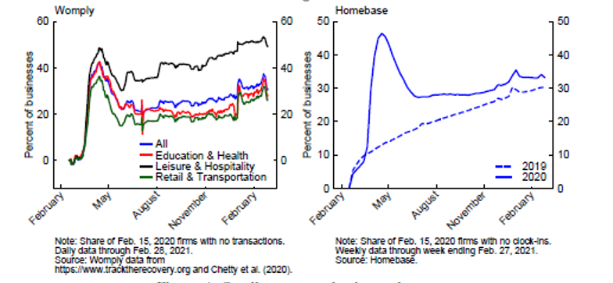

As shown in Figure 9, the 2020 Womply data is hard to interpret, as it is difficult to translate what a near 40 percent closure rate says about true business exit. In contrast, the longer time series we have for Homebase, allows a comparison with 2019 figures. By February of 2021, exit in the Homebase series was a striking 33 percent above its pre-pandemic levels. But, once that number is compared to the 2019 attrition rate, it is clear that excess exit was only about 3 percentage points, a much less worrisome picture.

A third disadvantage of the lack of historical data for many of the pandemic-related series is that there is little to no track record to see how these data translate to or predict standard data sources. And, even if there is, the past relationships may no longer hold due to the pandemic reshuffling of the economic landscape. A good example of this is the “high-propensity” business applications from the weekly Business Formation Statistics (BFS) from the Census Bureau. The BFS depend on the historical relationship between business applications (EINS) and establishment formation. That is how IRS EIN applications translate into establishments that maintain active payroll.

**Figure 10. New Business Applications**

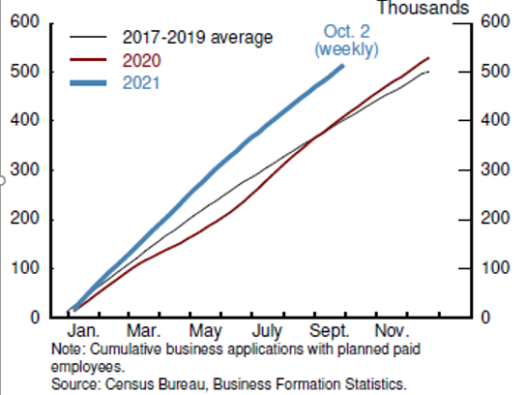

The series in Figure 10 show that EIN applications increased sharply in the second year of the pandemic. In normal times, this would imply healthy growth in new business entry. Unfortunately, the relationship between EINs and new establishments with active payroll might no longer hold. This could result from business applications covering an entirely new form of venture or new “work from home” businesses that do not employ workers expanding rapidly during the pandemic.[19] Due to lags in the publication of official data on business entry—a similar problem to the data on exit mentioned above—it could be years before we know if the BFS “businesses” show up in official data.

Beyond short time series, nontraditional data face additional hurdles that may make them unreliable. The fact that they may be non-representative presents one of the largest hurdles. Many of the databases that were most helpful during the pandemic-recession were sampled from client bases and firms’ administrative records that represent only a small fraction of the overall population of activity one would want to track. Small samples are not necessarily an insurmountable hurdle to representative aggregates, because low-level aggregates could be weighted and benchmarked to properly reflect a particular population. For example, the ADP-FRB series—which is roughly based on a sample of 20 percent of employment—requires weights from the Quarterly Census of Employment and Wages (QCEW) to be “made” representative of overall employment. This approach is similar to the BLS’ use of QCEW weights for its payroll data. This contrasts with Homebase data, which have become an important indicator for small business employment and activity during the pandemic.[20] Homebase is a scheduling and time-tracking tool used mostly by small businesses—it covers just 2 percent of employment and 1 percent of establishments in the accommodation and food services industry. And this comparison is within a sector Homebase covers well. For other services, the coverage is much smaller--in the tenths of a percent. [21] Unfortunately, the small sample issue is compounded with sample selection issues, as the sample is just the customer base and there is a significant amount of churn within the sample of firms employing Homebase. This is typical of most opportunity surveys, and researchers generally lack a way of weighting the data to make it representative of the whole economy. Representativeness problems are exacerbated when attempting to delve into the industry, geographic, or demographic heterogeneity of the data series.

Another hurdle for nontraditional data is methodological changes. For traditional data, these are typically folded into federal statistical releases during annual or comprehensive revisions and most often are accompanied by a revision to the historical data so that the time series is consistent. This is not necessarily the case with nontraditional data, as the data collection and provision of statistics are fundamentally not the focus of the enterprise which releases the data. Two examples illuminate this situation. Kastle occupancy reports, which used keycards as a metric of employees return to work in person, changed methodology from daily to weekly data in March 2021. Fortunately, Kastle re-estimated the entire time series with the new methodology. On the other hand, Safegraph, a company that aggregates anonymized location data from numerous mobile device applications to provide insights about physical places, changed their methodology for imputing where devices are in March 2021. Because they did not re-estimate the historical data, the series suggests there was an abrupt change in social distancing measures in March of 2021 when that is likely not the case.

Another hurdle is that sometimes nontraditional data series just cease. As the pandemic has dragged on, several organizations have stopped reporting data. For example, the Yale labor survey (YLS), an online survey of households akin to the Current Population Survey that started collecting and publishing data in April of 2020, provided rapid and inexpensive information on employment, unemployment, and other labor-market measures that tracked the official measures well but provided more frequent and timelier data.[22] The last YLS covers the week ending February 27, 2021. Somewhat similar, a portion of the Census’ Small Business and Household Pulse surveys started and paused or stopped altogether as the Census revised the survey and added new questions. For example, data items that were rotated off the Small Business Pulse survey—series that would have been useful in all phases—included temporary closures, supply chain questions, planned capital expenditures, rehiring, and remote work. Lastly, the Covid Tracking Project—a well-organized, formatted, and consistent purveyor of Covid health data—stopped collecting new data in March of 2021. And while the Federal health data improved over the course of the pandemic, the sources and structure varied tremendously, leading researchers and policy officials scrambling for alternative sources of information.

One final hurdle for nontraditional data is that it is sometimes so noisy that it provides little signal for the economic indicators of interest. Moreover, even indicators that did well at the height of the pandemic, such as Google Trends ability to predict unemployment claims and Homebase providing insight into overall employment, might be less helpful once the period in which dramatic swings in activity were all highly correlated moves further in the past. To gauge their value, all these measures should be evaluated for their signal content outside of the dramatic 2020 months and when the forecasting framework includes additional indicators of economic activity.[23]

1. **Conclusions**

Nontraditional economic data were an important resource for policymakers during the pandemic downturn and recovery. These alternative data sources provided a view into economic activity weeks or months before most traditional data would become available. In addition, these data illuminated household and business activity at a granular level, which helped clarify the mechanisms affecting the pandemic economy. Having access to nontraditional data specific to this episode also allowed policymakers insight into how the virus and associated health policies were evolving. One important question is whether these data were valuable only because of the unusual and rapid nature of the recent downturn, or whether they will be important in future economic crises.

At the onset of any crisis, economic policymakers need to identify whether they are confronting a demand shock or a supply shock and the magnitudes and likely persistence of those shocks. As the episode unfolds, policymakers also want to understand how the shocks are propagating to the broader economy. Consequently, many of the series used in the Pandemic Recession will likely prove useful in most downturns: Daily point-of-sale card swipe data, surveys of consumer sentiment, and credit card data, as well as weekly automotive transactions should give an early warning of shocks to demand. And understanding the propagation of shocks to the rest of the economy may be aided by data from payroll processors, business exits/entries, or signals of supply chain disruption. In the Global Financial Crisis, we learned that access to and the ability to easily use data on short-term funding markets, such as CP data, were important resources. These are some of the series we need to have and understand for every crisis, and we should plan ahead for the next crisis by investing in nontraditional data sources now—to build longer time series of timely indexes to supplement the traditional data sources, to improve the usability of existing data, to validate the granular details that may be available and become important during a downturn, and to hone our skills in working with these data. Even if these nontraditional data sources have limited use during an expansion, it is worth developing them to be prepared for the next crisis, the next government shutdown, or the unexpected.

Some shocks, often supply shocks, seem more idiosyncratic across episodes and so the relevant data are as well. In the 1970s, timely data on global oil markets and inflation expectations would have been valuable but were largely unavailable. In the most recent recession, COVID-19 hospitalization and data on public shutdowns were valuable, but seem unlikely to be important in future cyclical events. It is hard to know what types of idiosyncratic series will be valuable in future episodes, but a culture that embraces transparency and data sharing can only help.

It is also important to understand the pitfalls of using nontraditional data. The absence of a long time series in many of these series hinders seasonal adjustment, makes levels difficult to interpret, and impedes comparisons at a business cycle frequency. These data can also be unreliable because they are nonrepresentative, methodological inconsistent, highly variable and/or noisy, or just because the entity collecting or making available the data may stop doing so. The resources to develop the human capital to address these issues are large—and that is over and above buying the data themselves.

Nonetheless, we view the benefits of nontraditional data as much greater than the costs. And some of the learning is still ahead of us. As the COVID-19 crisis is still evolving, a full accounting is still to come. High-frequency, granular data will probably continue to reveal aspects of business cycle dynamics that we can learn from for many years.

**References**

Autor, David, David Cho, Leland D. Crane, Mita Goldar, Byron Lutz, Joshua Montes, William B. Peterman, David Ratner, Daniel Villar, and Ahu Yildirmaz (forthcoming). “An Evaluation of the Paycheck Protection Program using Administrative Payroll Microdata,” Journal of Public Economics.

Baker, Scott, R.A. Farrokhnia, Steffen Meyer, Michaela Pagel, and Constantine Yannelis (forthcoming). “Income, Liquidity, and the Consumption Response to the 2020 Economic Stimulus Payments,” Review of Finance.

Bartik, Alexander W., Marianne Bertrand, Feng Lin, Jesse Rothstein, and Matthew Unrath (2020). “Measuring the Labor Market at the Onset of the COVID-19 Crisis,” Brookings Papers on Economic Activity, Summer 2020, Special Edition, pp. 239-268.

Bartlett, Robert P. III and Adair Morse (2020). “Small Business Survival Capabilities and Policy Effectiveness: Evidence from Oakland,” NBER Working Paper No. 27629.

Bitler, Marianne P., Hilary W. Hoynes, and Diane Whitmore Schanzenbach (2020). “The Social Safety Net in the Wake of COVID-19,” Brookings Papers on Economic Activity, Summer 2020, Special Edition, pp. 119-158.

Cajner, Tomaz, Leland Crane, Ryan A. Decker, Adrian Hamins-Puertolas, Christopher Kurz, and Tyler Radler (2018). “Using Payroll Processor Microdata to Measure Aggregate Labor Market Activity,” Board of Governors of the Federal Reserve System (U.S.) FEDS Working Paper 2018-005.

Cajner, Tomaz, Leland D. Crane, Ryan A. Decker, Adrian Hamins-Puertolas, and Christopher Kurz (forthcoming). “Improving the Accuracy of Economic Measurement with Multiple Data Sources: The Case of Payroll Employment Data,” in Big Data for 21st Century Economic Statistics, edited by Katharine G. Abraham, Ron S. Jarmin, Brian Moyer, and Matthew D. Shapiro. Chicago: University of Chicago Press.

Cajner, Tomaz, Leland D. Crane, Ryan A. Decker, John Grigsby, Adrian Hamins-Puertolas, Erik Hurst, Christopher Kurz, and Ahu Yildirmaz (2020a). “The US Labor Market during the Beginning of the Pandemic Recession,” Brookings Papers on Economic Activity, Summer 2020, Special Edition, pp. 3-33.

Cajner, Tomaz, Andrew Figura, Brendan M. Price, David Ratner, and Alison Weingarden (2020b). “Reconciling Unemployment Claims with Job Losses in the First Months of the COVID-19 Crisis,” Finance and Economics Discussion Series 2020-055. Board of Governors of the Federal Reserve System (U.S.).

Cajner, Tomaz, Leland D. Crane, Ryan A. Decker, Adrian Hamins-Puertolas, and Christopher Kurz (2020c). “Tracking Labor Market Developments during the COVID-19 Pandemic: A Preliminary Assessment,” Finance and Economics Discussion Series 2020-030. Board of Governors of the Federal Reserve System (U.S.).

Chetty, Raj, John Friedman, Nathaniel Hendren, Michael Stepner, and the Opportunity Insights Team (2020). “How Did COVID-19 and Stabilization Policies Affect Spending and Employment? A New Real-Time Economic Tracker Based on Private Sector Data,” NBER Working Paper No. 26463.

Cleveland, William P., and Stuart Scott (2007). “Seasonal Adjustment of Weekly Time Series with Application to Unemployment Insurance Claims and Steel Production,” Journal of Official Statistics, 23(2): pp. 209–221.

Coombs, Kyle, Arindrajit Dube, Calvin Jahnke, Raymond Kluender, Suresh Naidu, and Michael Stepner (2021). “Early Withdrawal of Pandemic Unemployment Insurance: Effects on Earnings, Employment and Consumption,” HBS Working PaperNo. 22-046*.*

Cox, Natalie, Peter Ganong, Pascal Noel, Joseph Vavra, Arlene Wong, Diana Farrell, Fiona Grieg, and Erica Deadman (2020). “Initial Impacts of the Pandemic on Consumer Behavior: Evidence from Linked Income, Spending, and Savings Data,” Brookings Papers on Economic Activity, Summer 2020, Special Edition, pp. 35-82.

Crane, Leland D., Ryan A. Decker, Aaron Flaaen, Adrian Hamins-Puertolas, and Christopher Kurz (2020). “Business Exit during the COVID-19 Pandemic: Non-Traditional Measures in Historical Context,” Finance and Economics Discussion Series 2020-089. Board of Governors of the Federal Reserve System (U.S.).

Dagum, Estela Bee (1988). “The X11ARIMA/88 Seasonal Adjustment Method - Foundations and User's Manual,” Time Series Research and Analysis Division. Statistics Canada Technical Report.

Ganong, Peter, Fiona Grieg, Max Liebeskind, Pascal Noel, Daniel Sullivan, Joseph Vavra (2021). “Spending and Job Search Impacts of Expanded Unemployment Benefits: Evidence from Administrative Micro Data”, University of Chicago, Becker Friedman Institute for Economics Working Paper No. 2021-19.

Hubbard, Glenn and Michael Strain (2020). “Has the Paycheck Protection Program Succeeded?” Brookings Papers on Economic Activity, Fall 2020, Special Edition, pp. 335-390.

Kurmann, Andre, Etienne Lale, and Lien Ta (2021). “The Impact of COVID-19 on Small Business Dynamics and Employment: Real-Time Estimates with Homebase Data,” Working Paper.

US Census Bureau (2008). “X-12-ARIMA Reference Manual,” Statistical Research Division, Census Bureau.

1. For example, in the first half of March, the near complete shutdowns of motor vehicle production in Italy and Spain and lower production rates in Germany and France provided guidance for forecasts of domestic light motor vehicle production.
2. The ADP-FRB data were available in real time to policymakers in the Federal Reserve System. For more details see Cajner et al. (2018, 2020a, forthcoming).
3. While initial claims for unemployment insurance were available at weekly frequency essentially in real-time, during the pandemic recession the translation of initial claims into employment losses was not straightforward, because initial claims overstated true employment losses. For more detail, see Cajner et al. (2020b).
4. While the ADP-FRB data are available to policymakers in the Federal Reserve System, Cajner et al. (2020c) released on April 16, 2020 the ADP-FRB data through April 4; those data already indicated job losses of 18 million.
5. Government data on other services spending—such as the Census’ QSS—come out with even more of a lag.
6. Given that there have been two government shutdowns in the past 10 years, both of which led to delays in government data releases, even outside the window of the actual shutdown, this benefit is not trivial.
7. The NBER dates the Great Recession from December of 2007 through June of 2009.
8. The Economist reported that “[r]esearch by Mr Chetty in early 2021 found that stimulus cheques sent in December boosted spending by lower-income households, but not much for richer households. He claims this informed the decision to place stronger income limits on the stimulus cheques sent in March.” See <https://www.economist.com/briefing/2021/10/23/enter-third-wave-economics>.
9. See Crane et al. (2020).
10. Two costs we do not address here, but are nevertheless worth consideration, are “hold up costs” and private companies trading on “insider” information from a nontraditional data release.
11. Moreover, many private data providers have consolidated. See https://www.forbes.com/sites/douglaslaney/2020/12/03/the-data-land-grab-continues-sp-global-to-acquire-ihs-markit/
12. That said, some firms recognize that the government is not using the data to make money but rather to understand economic/financial developments and to formulate public policy in a manner that benefits society, and price accordingly.
13. According to Census, the proper identification and estimation of seasonal and calendar effects requires a span of 10 to 15 years of data or a minimum is 5 years to properly estimate a seasonal pattern and 7 years for calendar effects and moving holidays. See Dagum (1988) and US Census Bureau (2008).
14. See Cleveland and Scott (2007) for details on weekly seasonal adjustment and <https://www.census.gov/data/software/x13as.html> for The Census Bureau information on X-13.
15. For a good example of this, see <https://www.census.gov/econ/indicators/COVID19FAQSAEIR.pdf>, which provides details on COVID-19’s effect on the Census’ Advance Economic Indicators. In particular, the FAQs discuss outlier adjustment processes.
16. Holiday effects can also be found in COVID-19 health data, including cases, hospitalizations, and deaths.
17. Similarly, the Census Pulse data was spliced with historical data from supplementary CPS questions. See Bitler et al. (2020).
18. Womply is a credit card processor and provides a measure firms that have ceased point-of-sale transactions while the Homebase clock-in and clock-out software facilitates tracking firms that have not had clock in events over a given period of time.
19. For example, if the average employment count of payroll maintaining establishments changes. One possibility during the pandemic could be a wholesale shift towards microbusinesses. See Harnman and Parilla (2022) at https://www.brookings.edu/blog/the-avenue/2022/01/04/microbusinesses-flourished-during-the-pandemic-now-we-must-tap-into-their-full-potential/
20. See Homebase, Kurmann, et al. (2021), Bartik et al. (2020), Bartlett and Morse (2020), and Granja et al. (2020).
21. These nontraditional indicators should be employed for aggregative forecasting with extreme caution, as a Homebase- based indicator predicted a job loss of more than 800,000 jobs in September of 2020, whereas employment increased by more than 300,000 jobs that month.
22. See <https://tobin.yale.edu/yale-labor-survey>
23. While there is evidence that nontraditional data inputs like credit card data and google trends improve forecasting, (see Boup et al. (2020) and D'Amuri and Marcucci (2017)) the gains are minimal when combined with the full suite of possible economic data that can be folded into a model (Li, 2016).